

Phan Nguyen Nhat Phuong

Executive summary:

This report provides a detailed review of Mega Transportation Company's sales performance throughout 2023. It discusses several key areas, including sales timing, geographical distribution, product lines, and customer engagement. The dataset, brought to life with visualizations, reveals sales trends with a noticeable upswing in the fourth quarter, particularly in November.

Geographical sales distribution notices the large proportion of sales in the USA, highlighting the effectiveness of a localized marketing strategy and a strong distribution network. In terms of products, “Classic Cars” represents the most lucrative product line, emphasizing a strong market preference that can inform future stocks and production plans.

Customer analysis identifies “Euro Shopping Channel” as the premier client, whose preferences can shape marketing initiatives and customer retention strategies. Moreover, the correlation between order status and sales volumes highlights the necessity to enhance logistic efficiency, as completed shipments significantly exceed in-process orders.

The report suggests four actions that MTC can adopt to boost profitability:
- Marketing and sales initiatives should be intensified during the fourth quarter.
- Expansion efforts should focus on high-performing regions and products to optimize resources.
- Customer relationship management should be maintained to grow the client base, especially with high-value customers.
- Supply chain processes must be optimized to minimize in-processed orders and maximize shipped sales.

Introduction

MTC, founded in 1975, has expanded from a local Albuquerque company to a vital player in the global transportation industry. The company specializes in a wide range of vehicles for the B2B market and has grown significantly in international markets. However, it is currently facing revenue issues because of increased competition and changing client behaviors. This issue necessitates a strategic, data-driven strategy. This is where the Sales Analysis Report for 2023 comes in. This report is a crucial analytical tool for understanding industry sales patterns. It leverages MTC's historical sales data and advanced analytics to provide data-driven insights for informed decision-making and boost competitiveness. As MTC faces a critical junction, this report is positioned to not only traverse the tough terrain ahead but also drive forward the company’s legacy of innovation and customer-centricity in the competitive transportation landscape.

- Sales Trends Analysis

1.1 Monthly Sales Trends

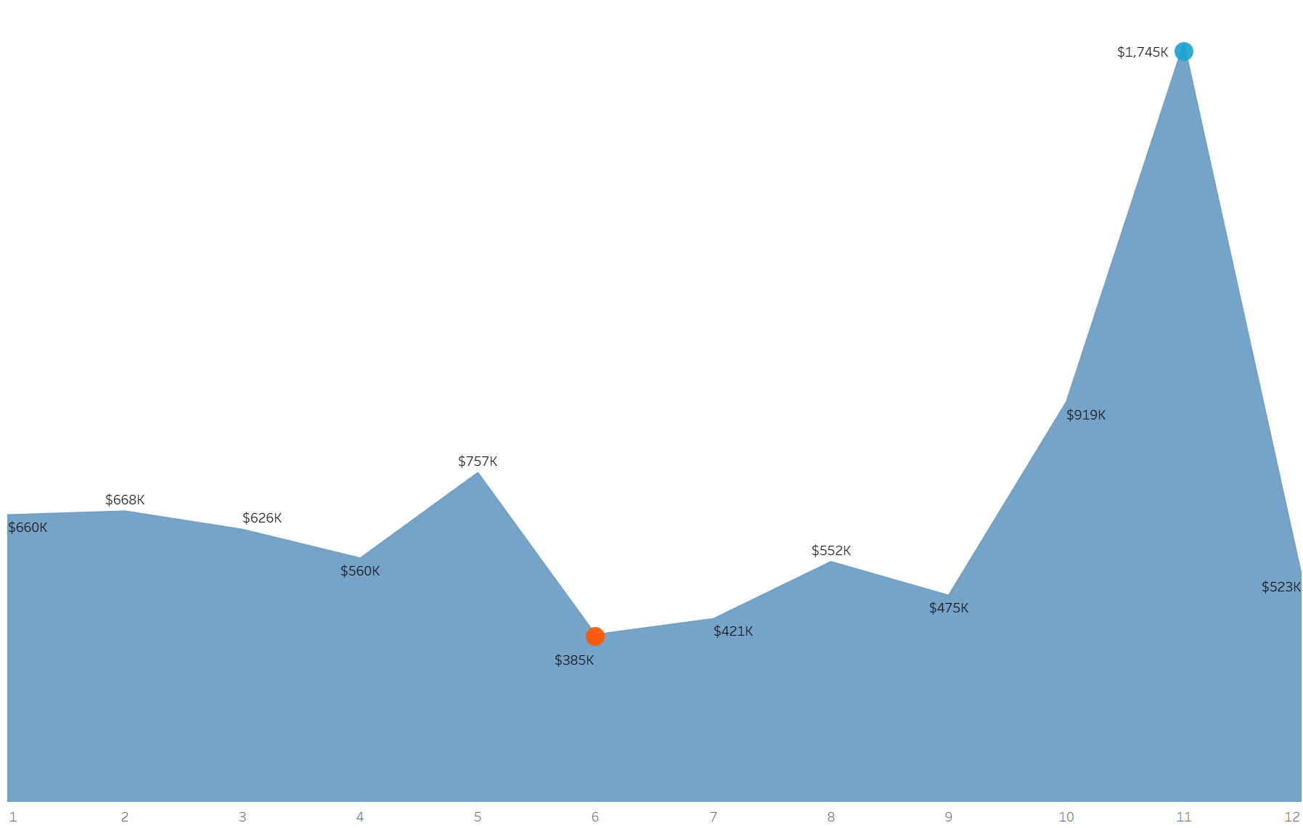

Figure 1.1: The total sales amount of MTCs every month in 2023
From a broader perspective, the annual sales trend generally declined compared to the initial month. As shown in Figure 1.1, sales started strong at $660k in January. However, the following months were volatile, peaking at $757k in May before dropping significantly to the year's lowest point of $385k in June, as symbolized by an orange dot on the graph. This substantial decline necessitates a thorough analysis of both market conditions and internal factors. Sales began to gradually increase from this low point, plateauing at $1.745K in November. This maximum, marked by a blue dot, suggests a year-end rise, possibly due to strategic sales drives and seasonal buying patterns. These factors highlight MTC's strong market engagement and the effectiveness of tailored sales strategies. After reaching this peak, sales fell sharply from $1,745K in November to $523K in December. This drastic decline was the largest month-to-month drop of the year, impacting on the annual sales performance and underscoring the need for strategic planning around the year-end. The varying monthly trends point to a closer examination of MTC's sales tactics and market impacts, with the goal of reducing lower levels and repeating tops in future sales initiatives.

1.2 Quarterly Sales Performance
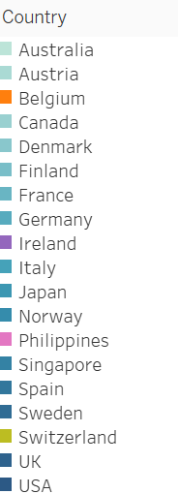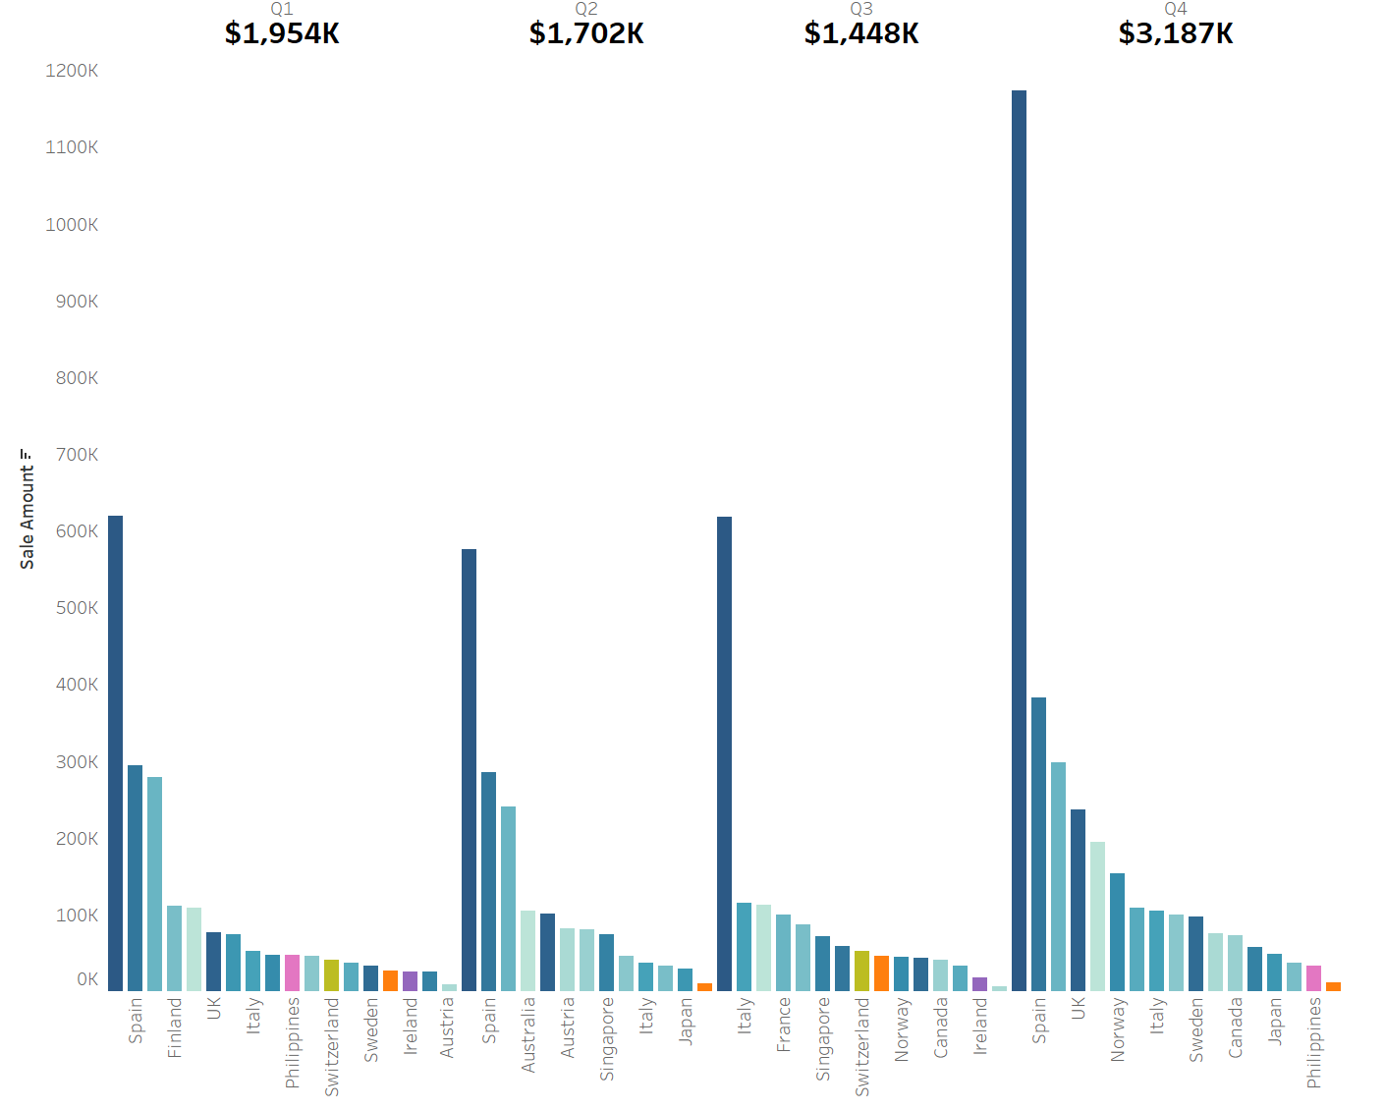
Figure 1.2: Total sales shown by quarter in 2023.

MTC’s quarterly sales performance fluctuated significantly throughout the year, peaking in Q4. As shown in Figure 1.2, Q1 began with significant sales of $1.954K, establishing a strong baseline for the year, followed by a slight reduction in Q2, which stabilized at $1.702K, and a further drop in Q3 to $1.448K, suggesting a mid-year adjustment in response to market changes or seasonal modifications. The focus point of the quarterly analysis is the dramatic increase in Q4, where sales soared to an exceptional $3.187K. This increase, more than double the revenue of any previous quarter, could be due to strategic year-end initiatives and favorable trading conditions for the transportation sector during this period. It underlines how targeted marketing strategies and seasonal industry patterns may affect MTC's sales volume. However, the significant increase in sales necessitates a cautious approach to resource allocation and market strategy. It is essential to understand the specific market drivers, consumer behavior, and internal processes that contribute to the Q4 peak, which helps to maintain a sustainable sales model that can navigate market volatility while leveraging high-performing periods, ultimately ensuring steady growth and stability for MTC.

- Geographic and product sales analysis

2.1 Sales distribution by country

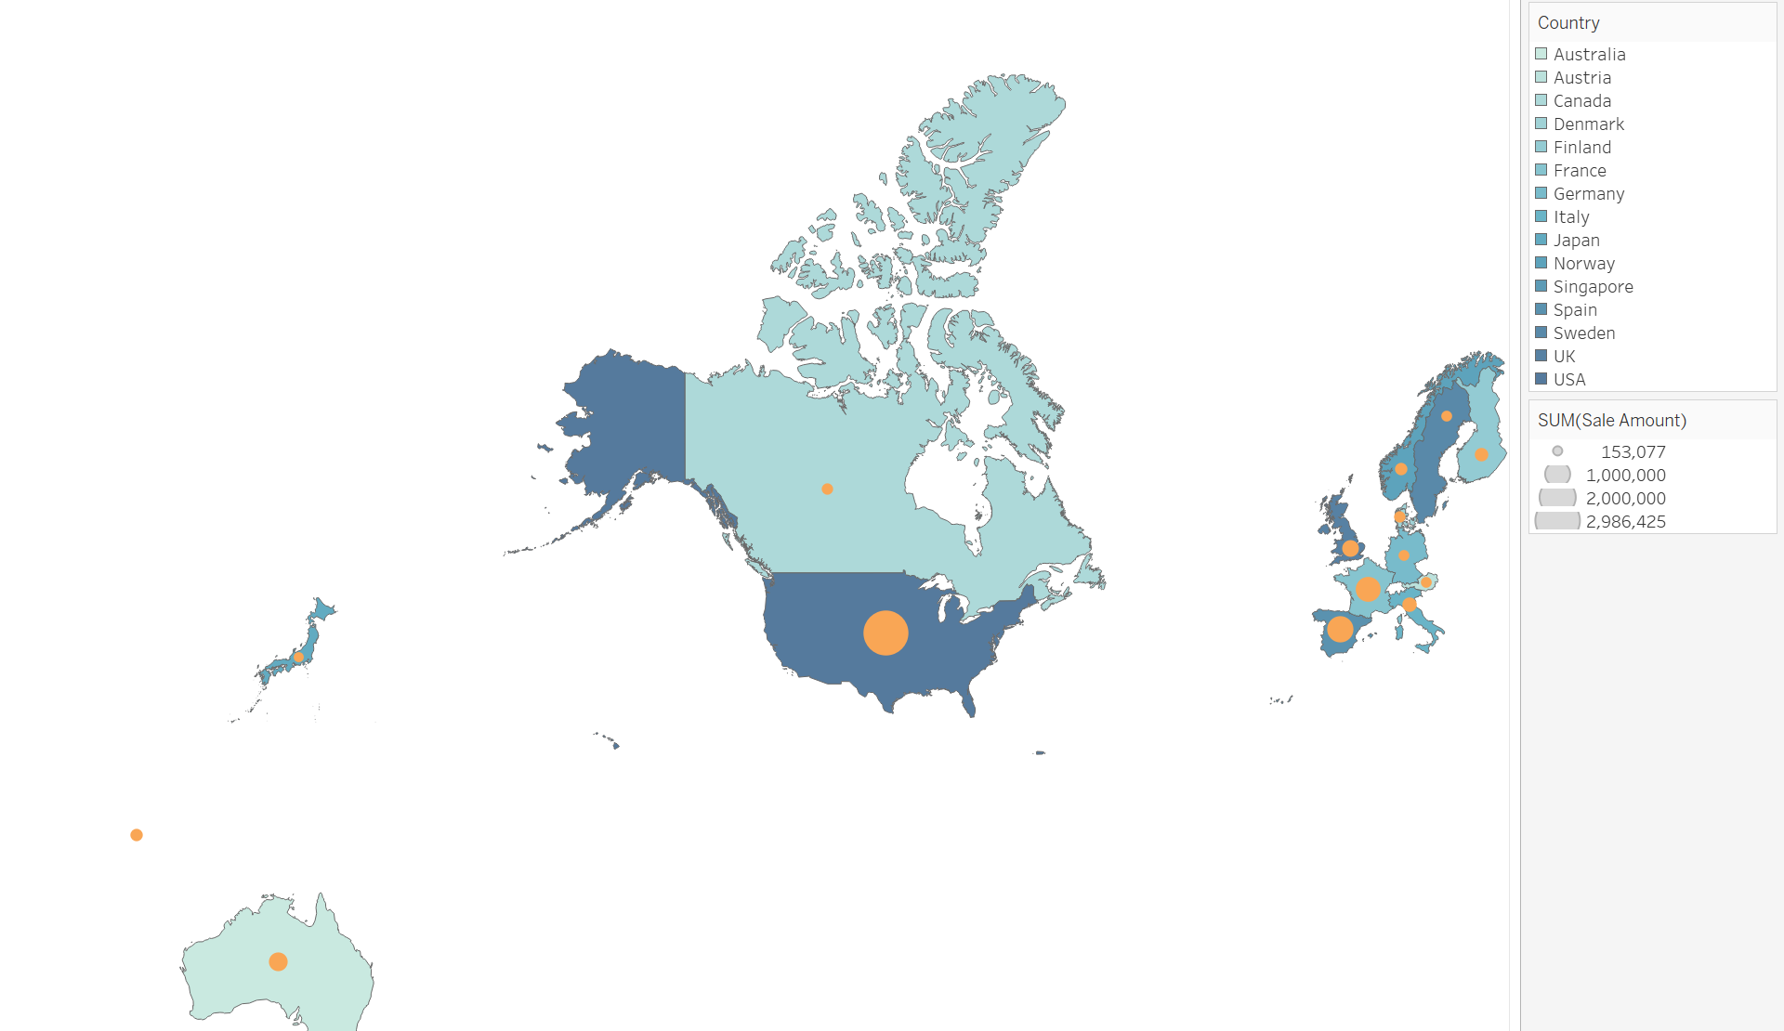

Figure 2.1 Total sales by country in 2023
Valuable insights can be drawn from each country, which can enhance the company's geographical strategy and market presence. According to Figure 2.1, the USA leads in sales revenue, generating a significant $2,986K. This showcases the USA's central role in MTC's market strategy, its strong distribution network, and robust domestic demand. Contrastingly, Japan, despite its economic standing, contributes a modest $153K to sales. The revenue disparity between these markets could indicate different levels of market penetration or different consumer preferences across regions. Despite being close to the United States, Canada's sales revenue is substantially lower, at around $194,000. Europe and the Middle East, grouped as the EMEA region, have a combined sales figure of around $1,000K, suggesting a balanced distribution across the region, probably due to MTC's strategic efforts to diversify market risks and leverage cross-regional opportunities. This strategy should go beyond basic proximity to understand regional demand, competitive dynamics, and market potential, which not only enhances its regional strategy but also strengthens its worldwide market presence, resulting in scalable growth.

2.2 Product Line Sales Analysis

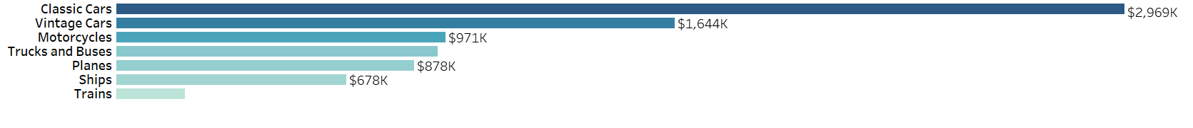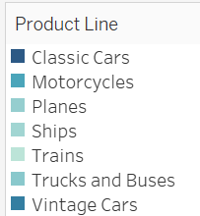
Figure 2.2 The bar chart displays the sales amount of each product line.
The sales performance by product line reveals diverse customer preferences and the strategic positioning of its product offerings. Classic Cars leads with impressive sales of $2,969K, as shown in figure 2.2, which is double the sales of Vintage Cars at $1,644K, the second-best performer. This significant preference for Classic Cars may indicate a successful product strategy that capitalizes on trends such as nostalgia or perceived value.
In comparison, the sales of Motorcycles, Trucks and Buses are quite similar, at $971K and $947K respectively, indicating a balanced demand in the mid-range sector. These categories could benefit from targeted marketing to increase their market share. Planes and Ships follow with sales of $878K and $678K respectively, representing a niche yet steady market segment. However, the sales of Trains are notably lower at $204K, suggesting either a lower market demand or less competitive offerings from MTC. MTC needs to identify the factors contributing to this product line's underperformance and assess potential strategic changes to boost sales. By aligning its portfolio with customer preferences and focusing on high-performing segments while improving lagging ones, MTC can strengthen its market position and optimize its product mix for continued revenue growth.

3. Customer and order analysis

3.1 Customer Sales Analysis
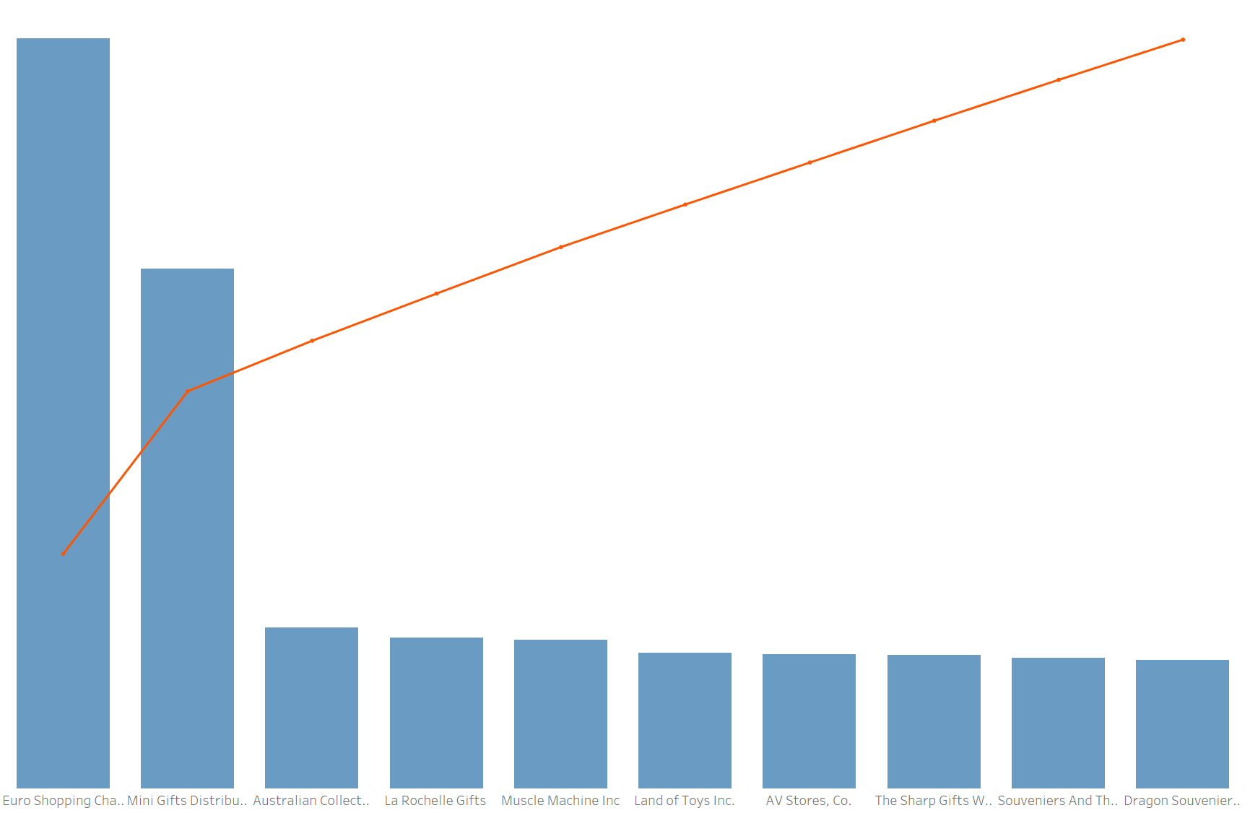
Figure 3.1.1: Top 10 customers with the highest total sales
Delving into the customer analysis, the Pareto chart (Figure 3.1.1) shows that the top 10 clients mainly contribute to MTC's revenue. The two main clients, Euro Shopping Channel and Mini Gifts Distributors Ltd., contribute $766K and $531K, respectively, demonstrating their strategic significance to MTC's revenue. The red line in the Pareto chart, representing the cumulative percentage of total sales, emphasizes the importance of these top clients. It rises sharply at the start, showing that a small group of clients’ accounts for a large portion of the revenue.
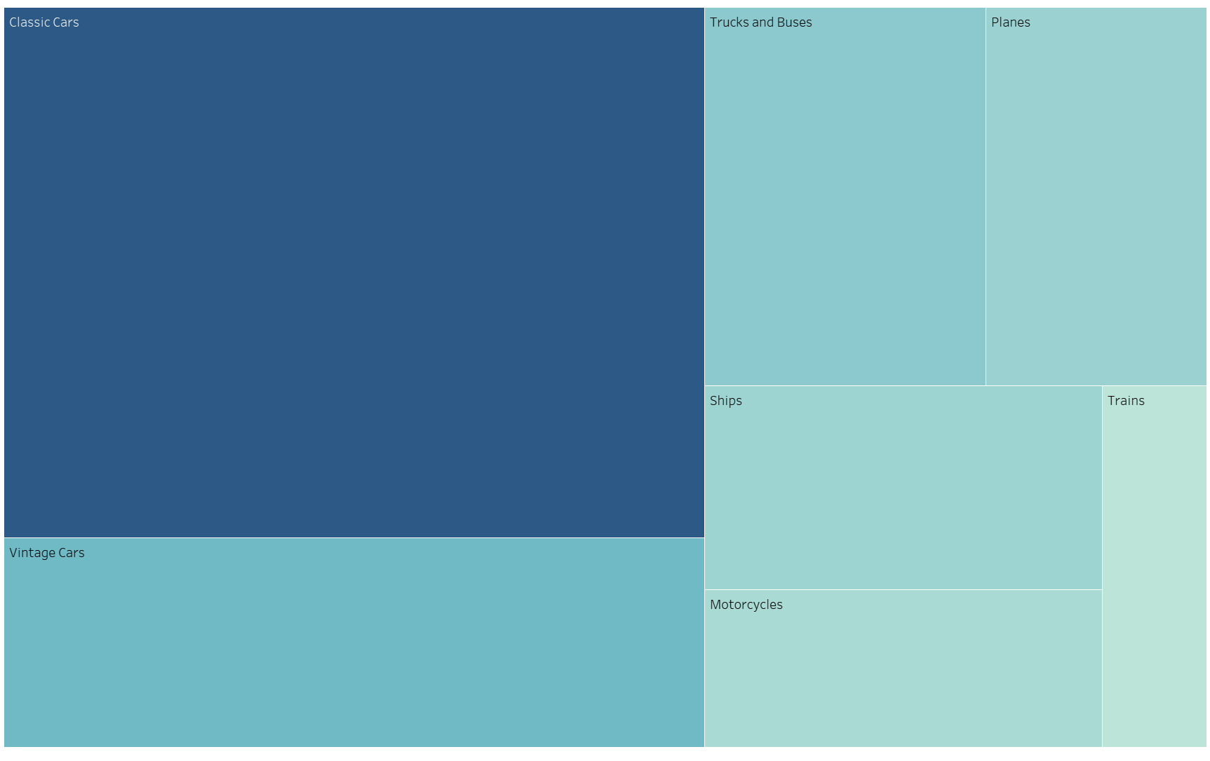
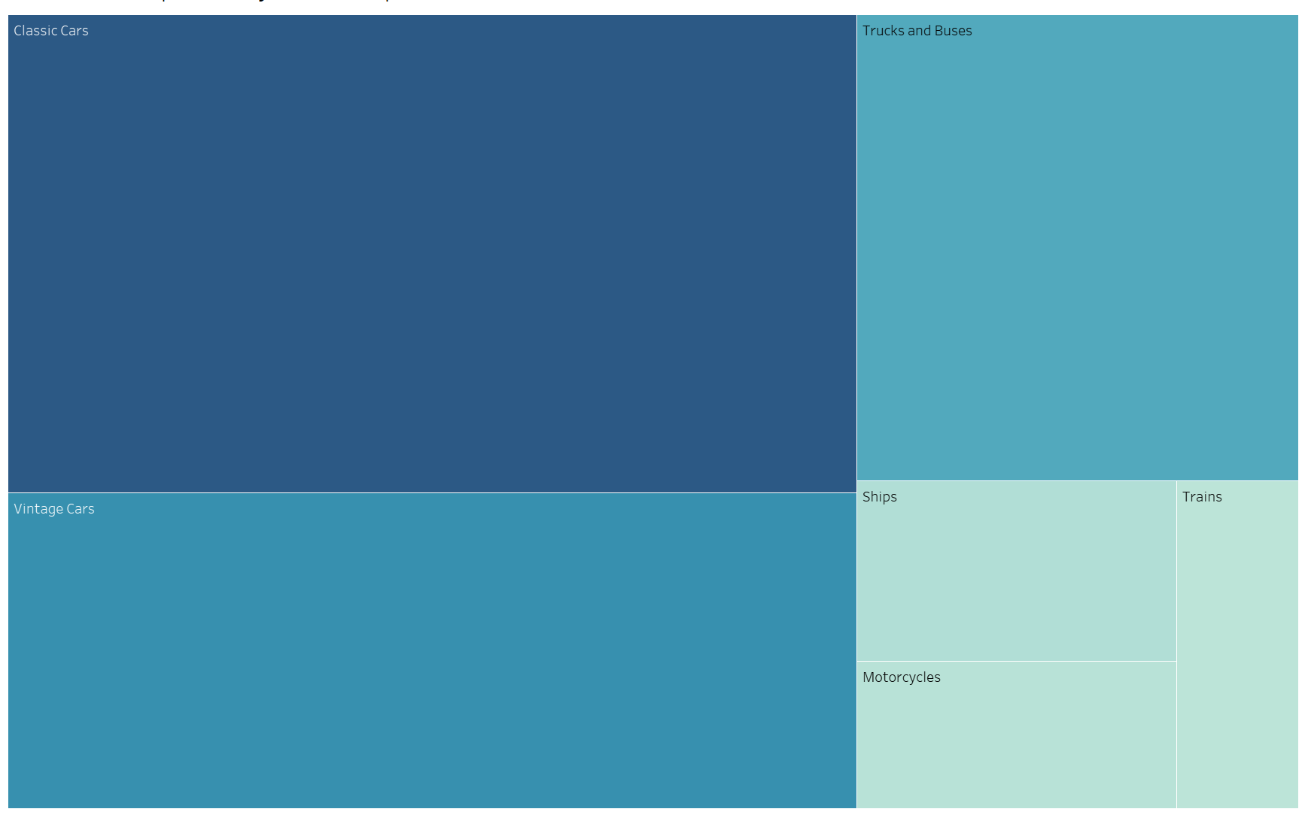
Figure 3.1.2: The two heatmaps show the sales distribution of the top two customers.
Figure 3.1.2 indicates our top client's preference for Classic and Vintage Cars, reflecting their significant sales contribution, which suggests a niche market for MTC to focus its marketing and production. This analysis provides significant insights into client relationships and purchasing behaviors, enabling MTC to refine strategies, enhance customer relations, and potentially expand high-demand product lines.

3.2 Order status impact on sales
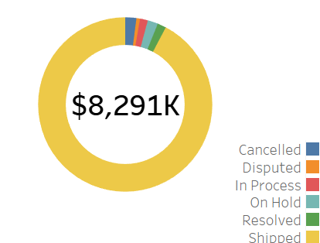
Figure 3.2. Total sales impact by order status
Given the product status, Figure 3.2 provides key insights into the impact of different order statuses on revenue and operational effectiveness. The 'Shipped' status, accounting for a significant 92% of total sales ($7,651K), demonstrates MTC's efficiency in order processing and delivery, both critical for revenue generation and customer satisfaction. The remaining statuses make up just 8% of sales. Notably, 'Cancelled' orders account for 2% ($171K), implying that MTC could enhance its customer service and order fulfillment operations to reduce cancellations. The 'On-Hold' and 'In-Process' statuses each represent about 1% of total sales ($121K and $159K, respectively). This highlights possible delays or uncertainties in the sales process, which could influence MTC's cash flow and overall supply chain fluidity. Addressing these order statuses can enhance both the bottom line and operational efficiency, leading to smoother logistics and increased productivity.

4. Pricing and Sales Correlation Analysis.

4.1 Price distribution by deal size
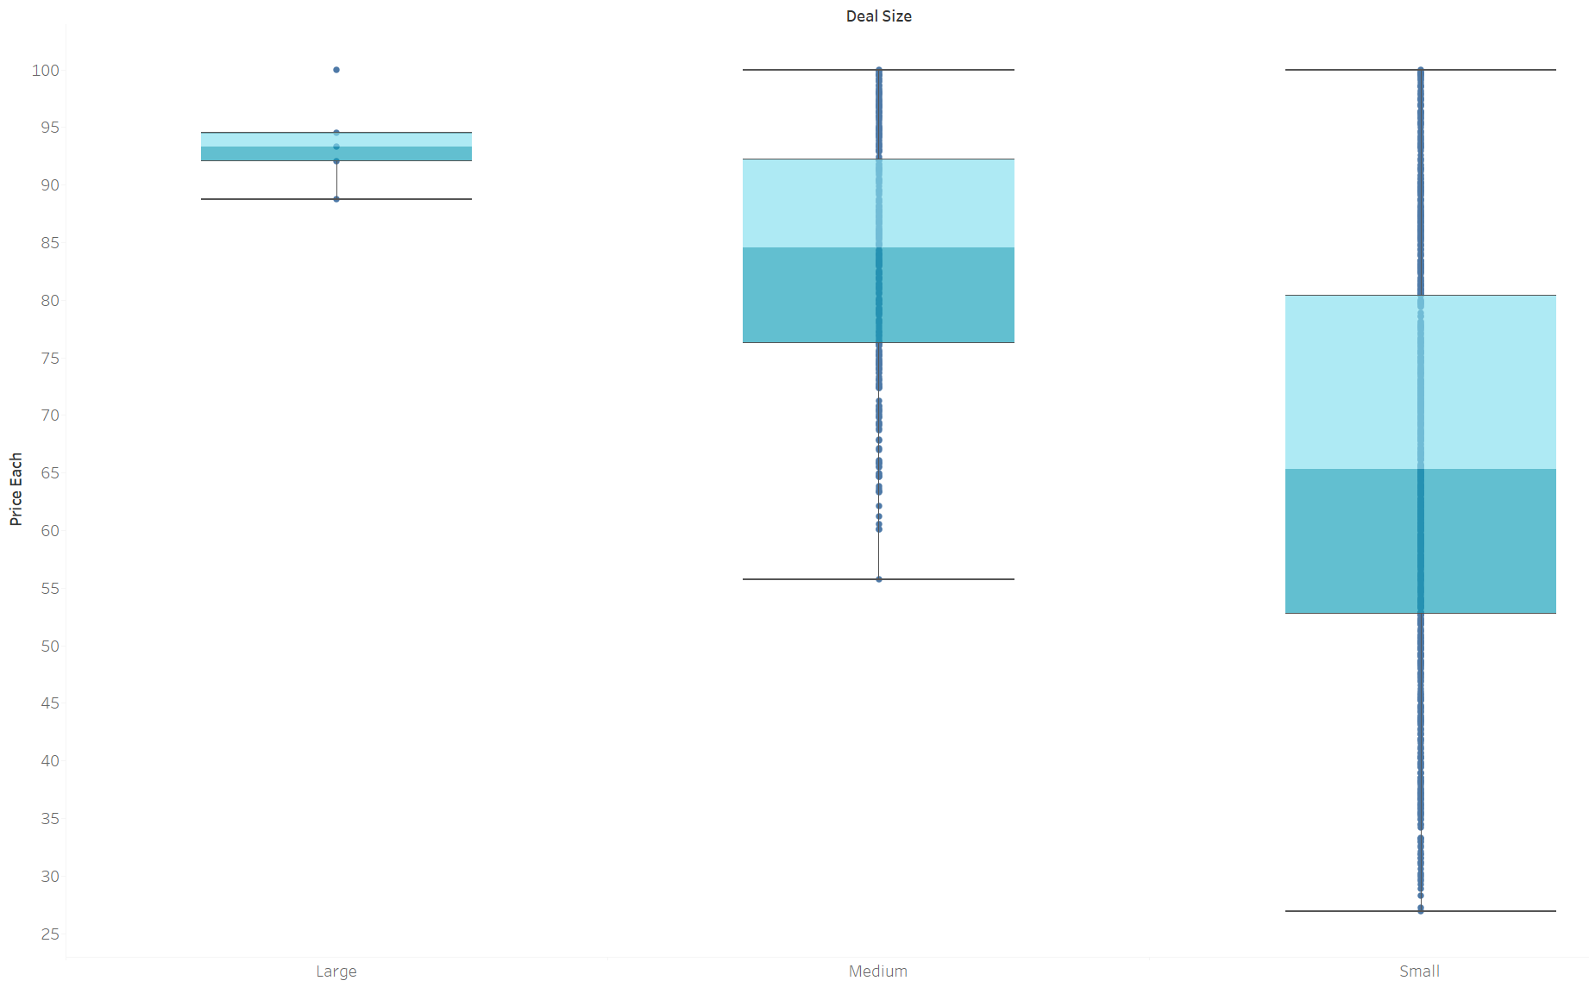
Figure 4.1: The boxplots show the price for each product according to the deal size.
Figure 4.1's boxplot visualization reveals that smaller deals typically have lower prices, with a median price of approximately $26.88 per product. This suggests a strategy of encouraging bulk purchases among price-sensitive consumers. As deal size increases, so does the median price. This is evident in medium-sized deals, which have a median price of $84.52 per product, and large deals, where prices average $93.28 per product. The price distribution for medium and small deal sizes at MTC shows a notable clustering of prices at the upper end of the box plots. This suggests that customers within these deal sizes have a high tolerance for MTC's pricing and may view higher-priced products as offering superior value. Reasons for this could include premium features, enhanced specifications, or perceived prestige associated with the company’s products. Additionally, economic factors such as material costs and competitive pricing dynamics might influence MTC's pricing strategy, pushing prices toward the upper range to align with market standards and competitor prices.

4.2 Sales Volume and Revenue Correlation
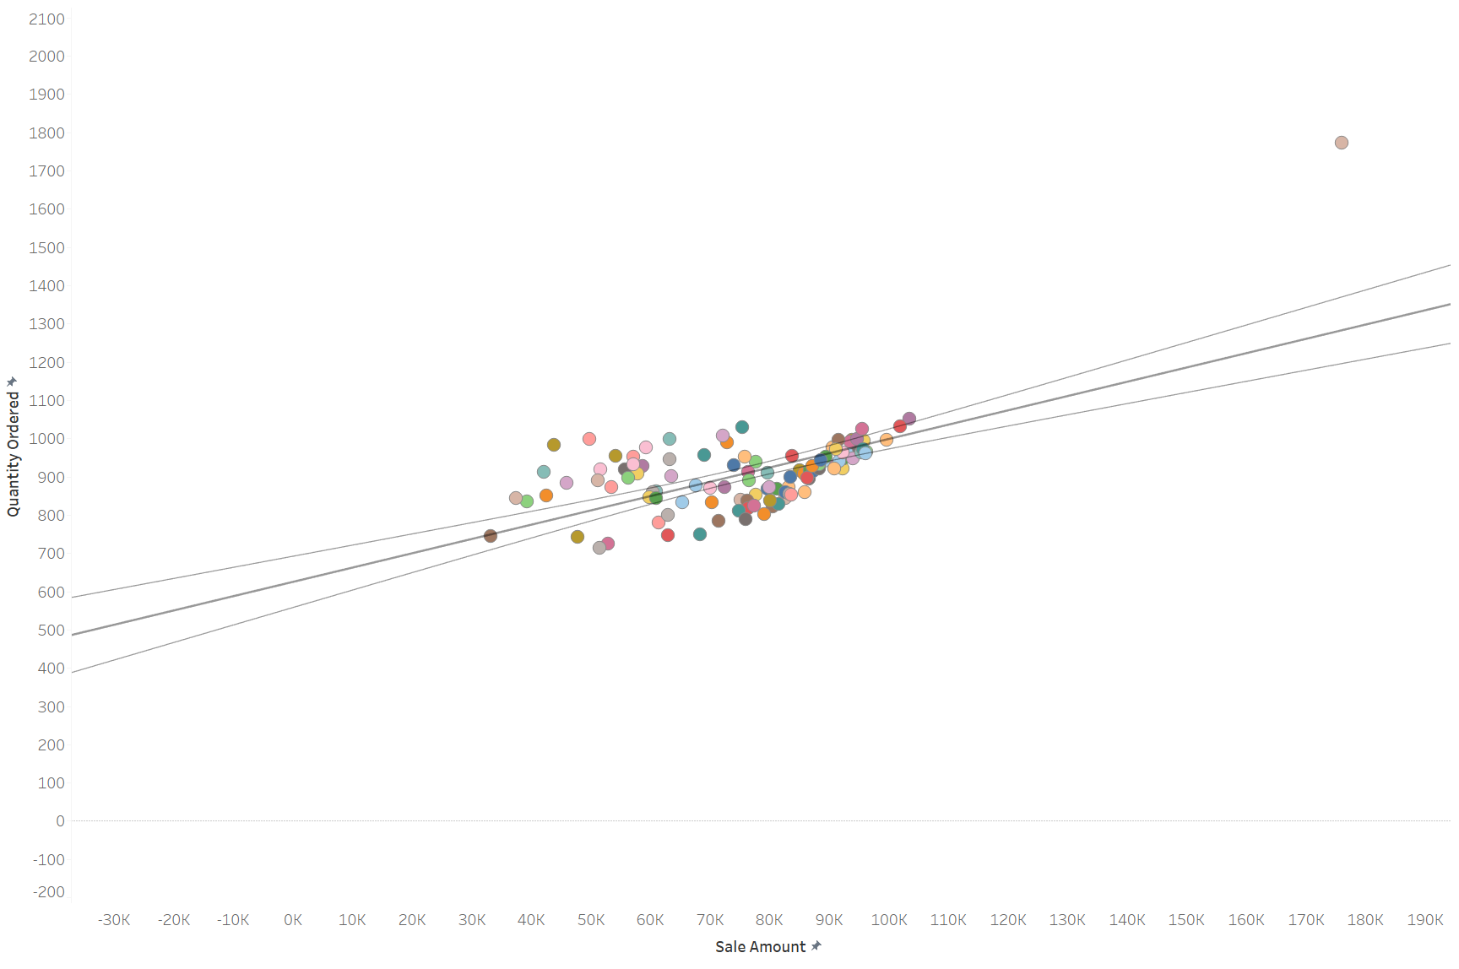
Figure 4.2: This scatter plot shows the correlation between sales volume and revenue.
According to Figure 4.2, the scatterplot depicting the correlation between sales volume and revenue indicates a strong linear relationship. This shows that as the quantity of products ordered increases, so does revenue. This trend is consistent across various data points and aligns closely with the regression line, emphasizing a strong positive correlation, leading to effective pricing strategies and well-segmented customer groups, where larger sales volumes result in proportional increases in revenue. However, the dataset shows an outlier: product code S18_3232, which has unusually high sales of $176,027 with a quantity ordered of 1,774. This deviation from the normal trend could indicate unusual conditions, such as bulk purchasing at a discount, a special promotion, or exceptional demand for this product. The occurrence of such outliers necessitates further investigation to understand the reasons behind these anomalies, ensuring they represent beneficial situations rather than problems with pricing or supply chain management.
5. Specified Analysis Section
In 2023, MTC reached significant sales milestones, demonstrating a strong market presence and strategic execution. The total sales for the year amounted to $8,291K. Analyzing this total by quarters, Q1 posted sales of $1,954K, Q2 had $1,702K, Q3 dipped slightly to $1,448K, and Q4 saw a substantial increase to $3,187K, marking a robust end to the year. The USA stood as the top-performing country, generating a noteworthy $2,986K in sales. This excellent performance reflects MTC’s effective market strategies and well-established distribution networks in the region. In terms of products, Classic Cars was the top-selling product line, totaling $2,969K in sales. The popularity of Classic Cars signals consumer preferences and MTC's ability to cater to market demand with high-quality, appealing products. The highest-performing company in terms of sales was Euro Shopping Channel, which mainly purchased Classic Cars, achieving sales of $766K. This partnership highlights the strength of MTC’s B2B relationships and its ability to serve major market players efficiently and accurately.

6. Recommendations
To enhance Mega Transportation Company's (MTC) sales performance and strengthen its market leadership, the following recommendations can be followed:
- MTC can improve customer engagement and retention strategies by launching targeted marketing campaigns and loyalty programs, especially for high-value product lines such as Classic Cars. Furthermore, they can offer personalized promotions, limited time offers, or exclusive early access to new models, which may foster customer loyalty.

- MTC can expand strategically in emerging markets. Given its success in established markets like the USA, MTC should identify and strategically enter emerging markets with considerable growth potential.

Dashboard
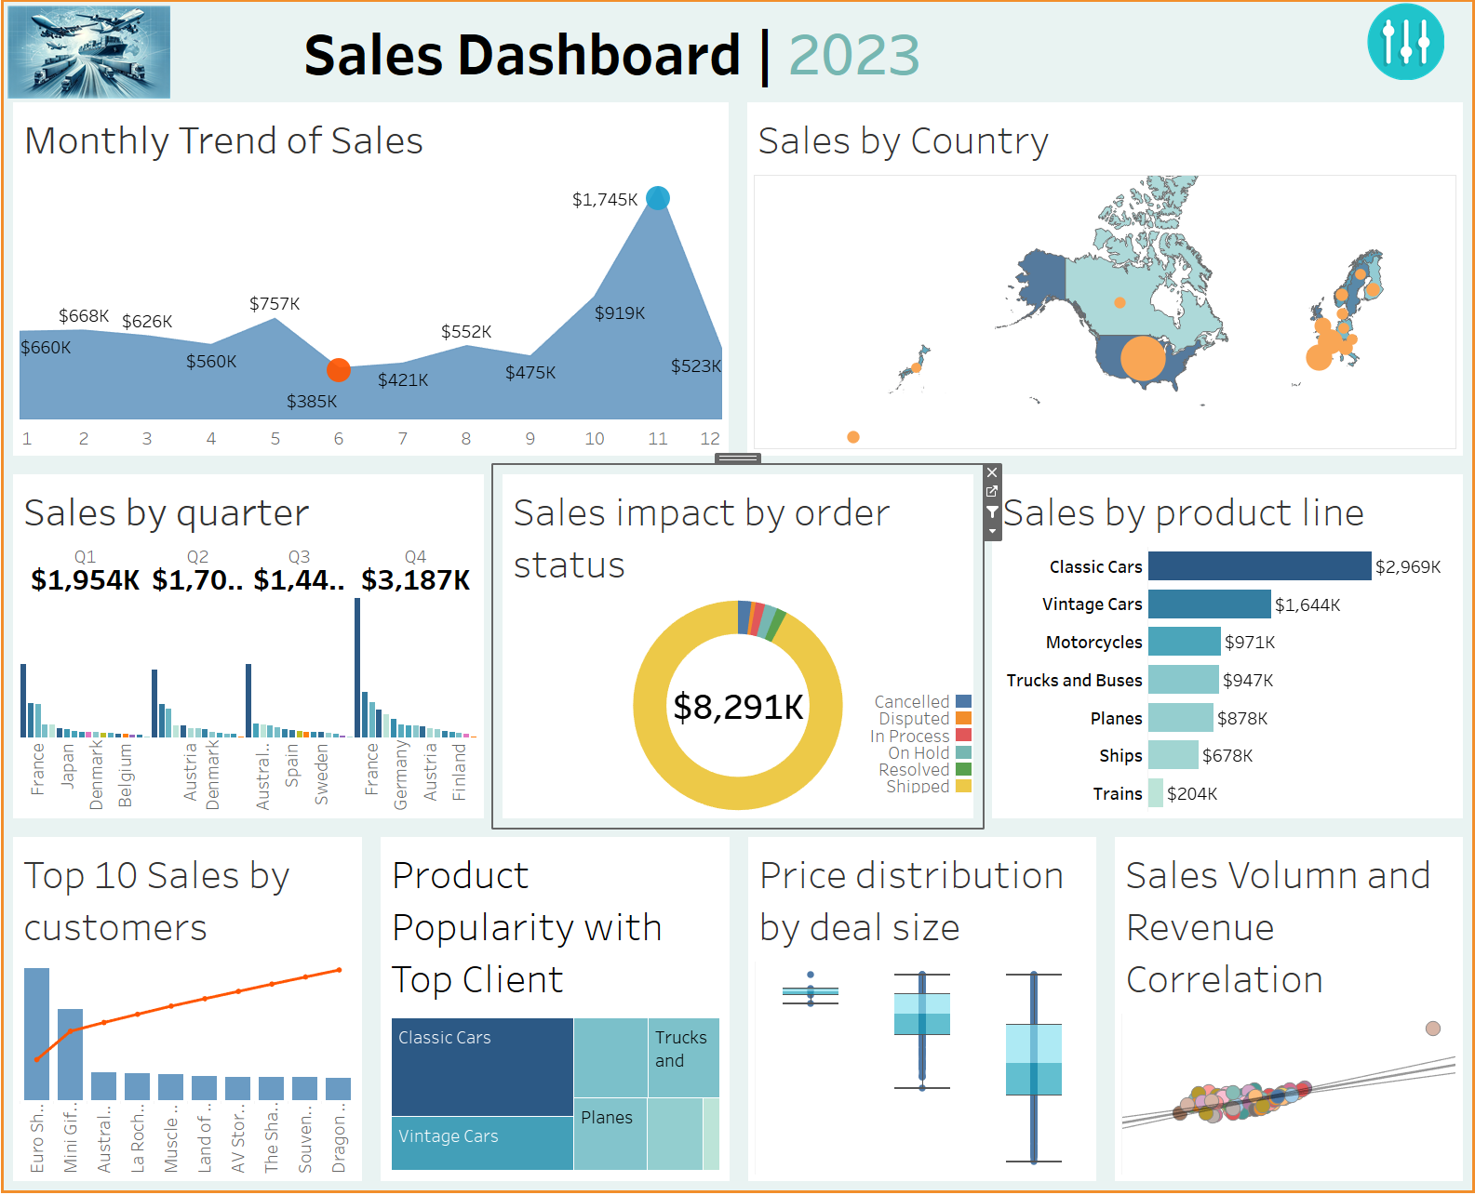

Note: To see the filter, click on button on the top right
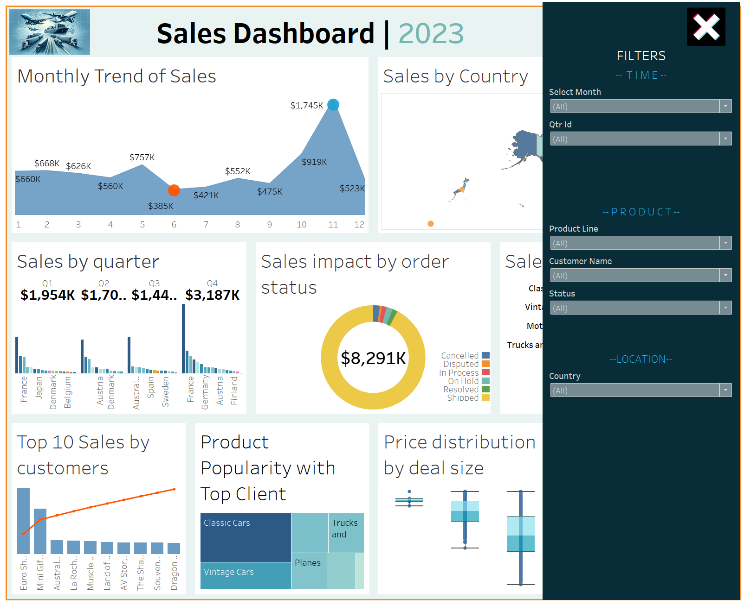

Acknowledgment Statement of Use of GAITs:
I acknowledge that I have not used GAITs (e.g., ChatGPT) in drafting and
proofreading this assignment

